MACH4METAL

metalworking machinery
Transito 21
6909 DA BABBERICH Netherlands
Tel. +31 (0)316-247123
Fax: +31 (0)316-247956
info@mach4metal.com
www.mach4metal.com

Bank No : 66.52.13.883
IBAN : NL33 INGB 0665 2138 83
BIC : INGBNL2A

CNC Pressbrake BEYELER EURO 4

- Make : Beyeler Swiss
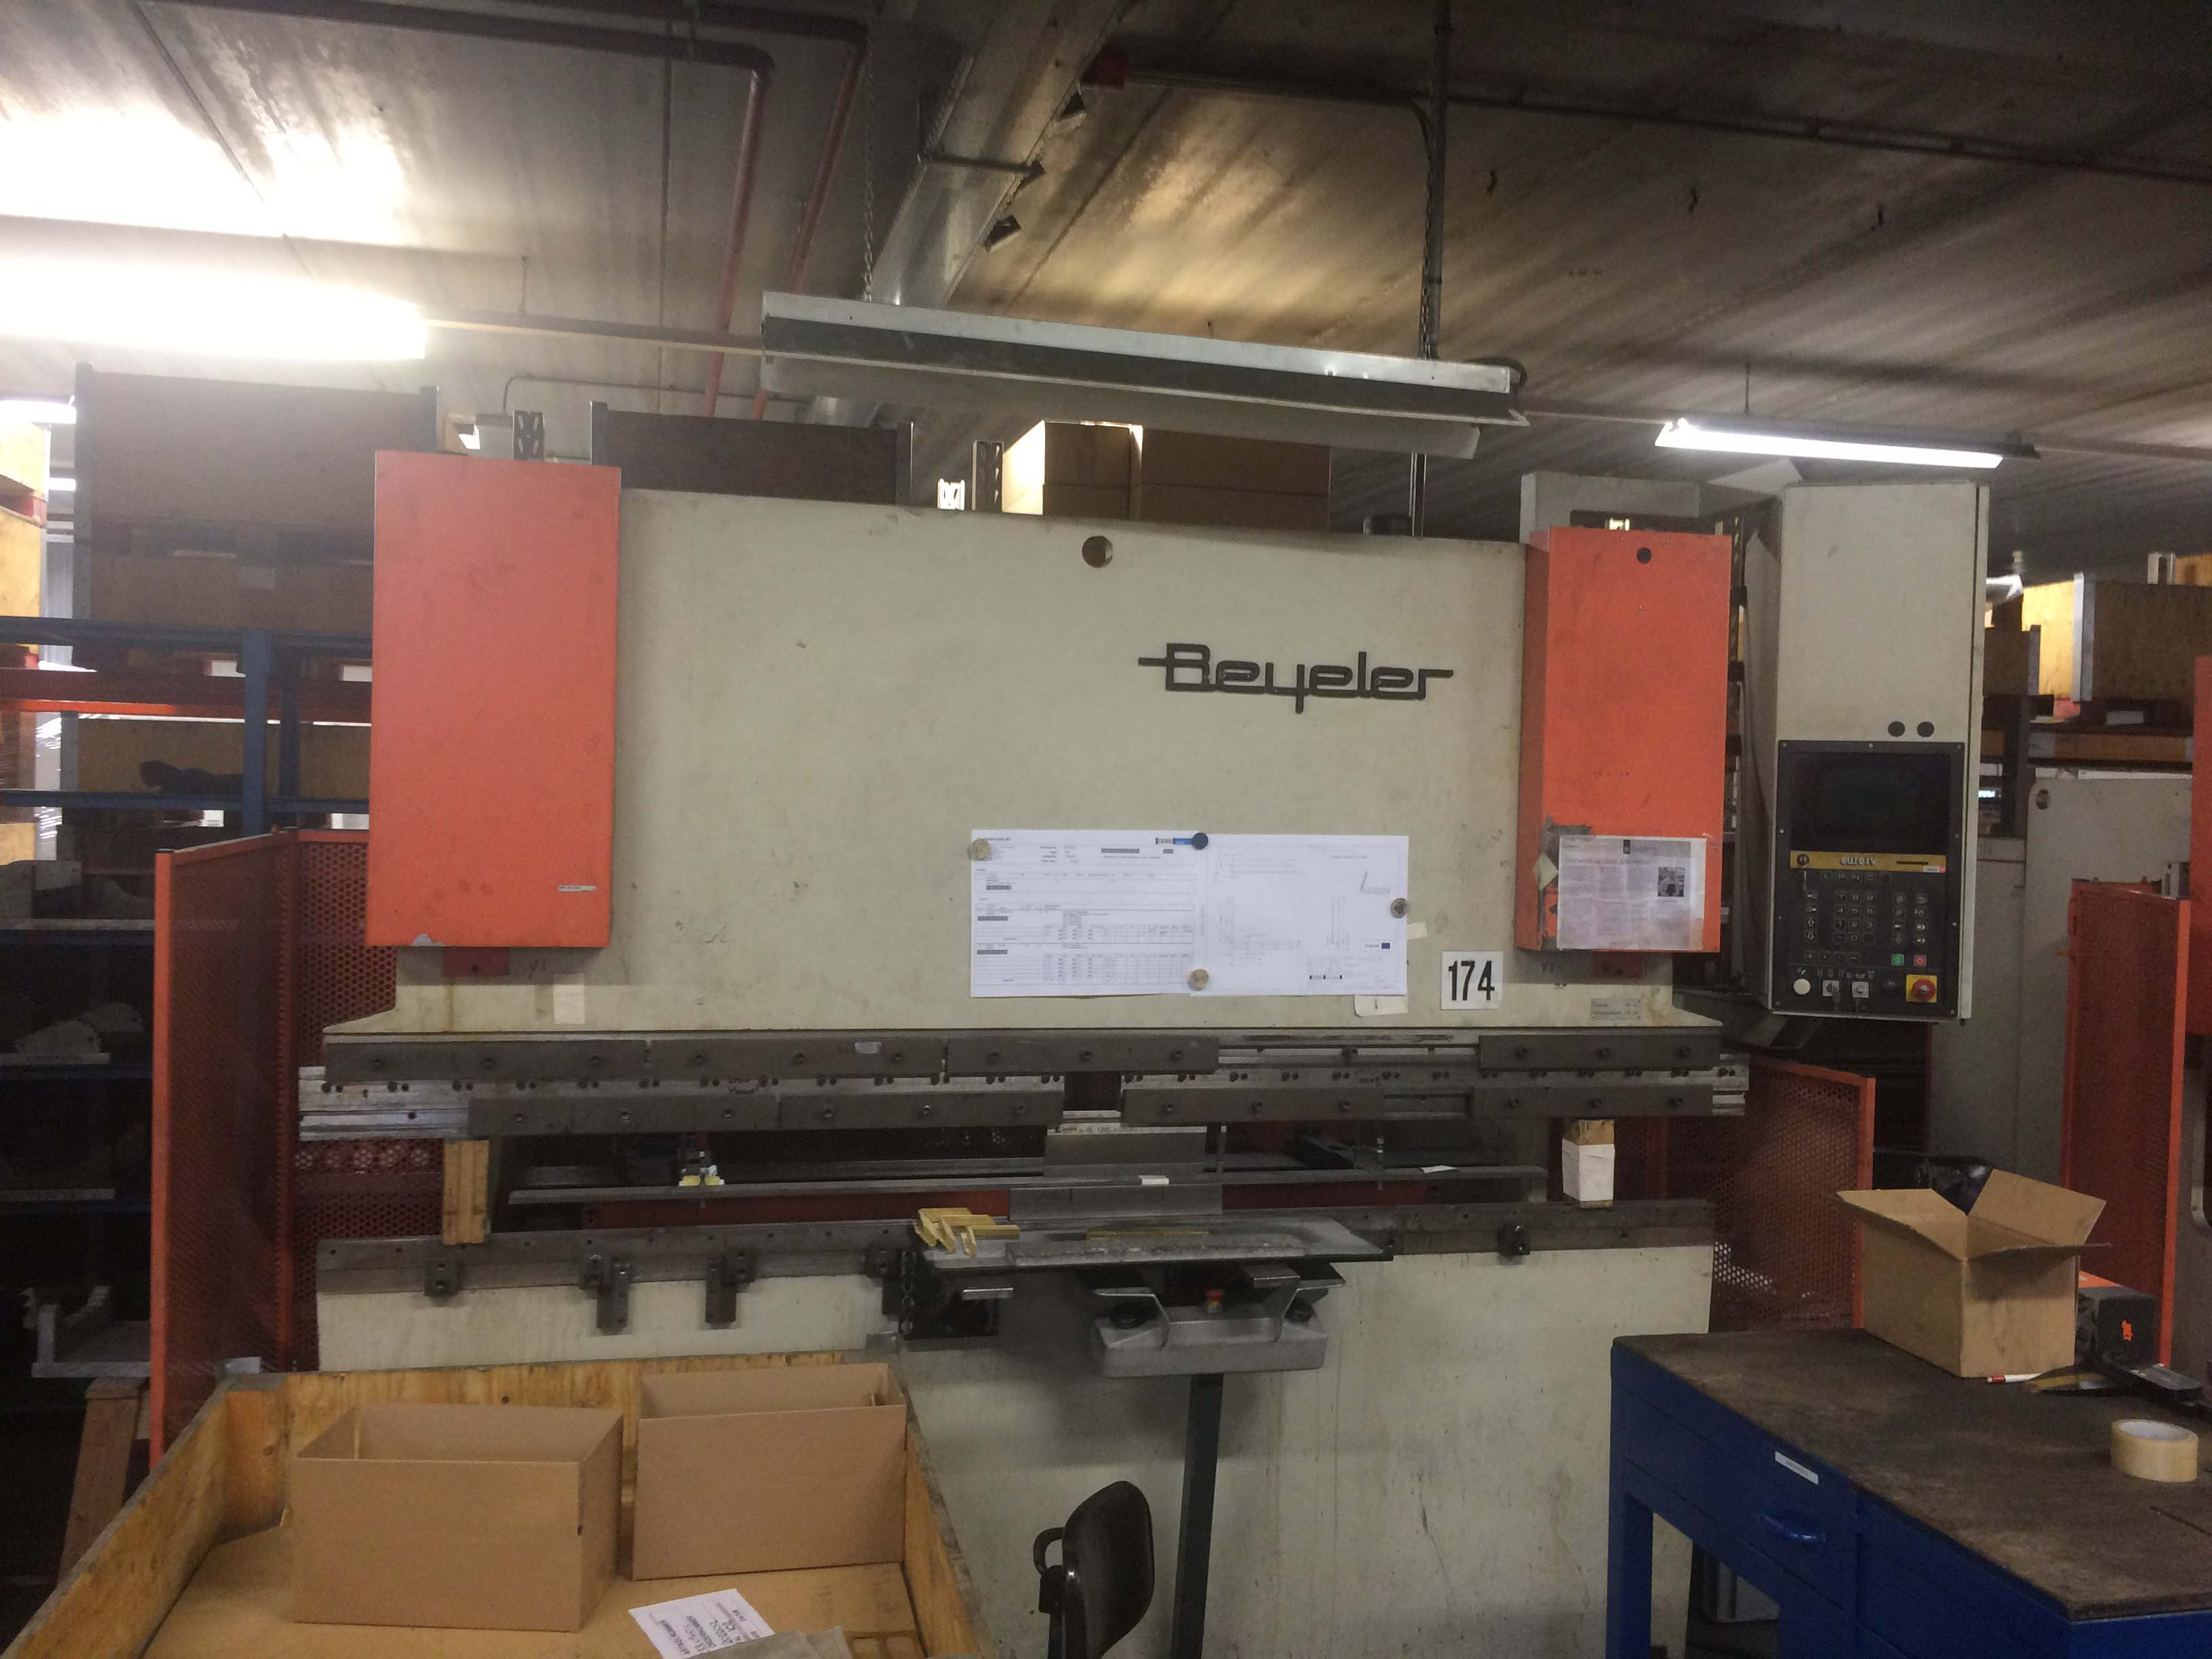
- Typ : EURO VI
- Age : 1993
- Mach.No : 93 / 230 / 005

- Max. bending length : 2.550
- Between column : 2.050
- Max. force : 60

- Die height : 360 mm
- Stroke adjustment : 165 mm
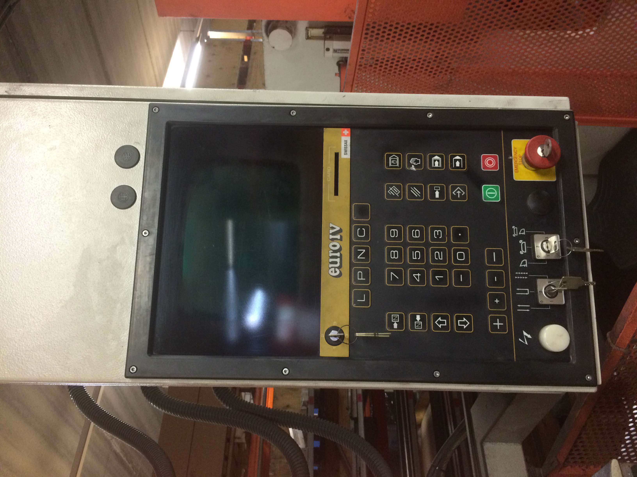
- Trot column : 255 mm

- Approach speed : 85 mm/min
- Working speed : 7 mm/min
- Return speed : 85 mm/min

- CNC Control Cybelec DNC EURO
- X Axis : 500 : 180 mm/s
- R Axis : 130 : 50 mm/s
- Z1 + Z2 : 400 : 300 mm/s
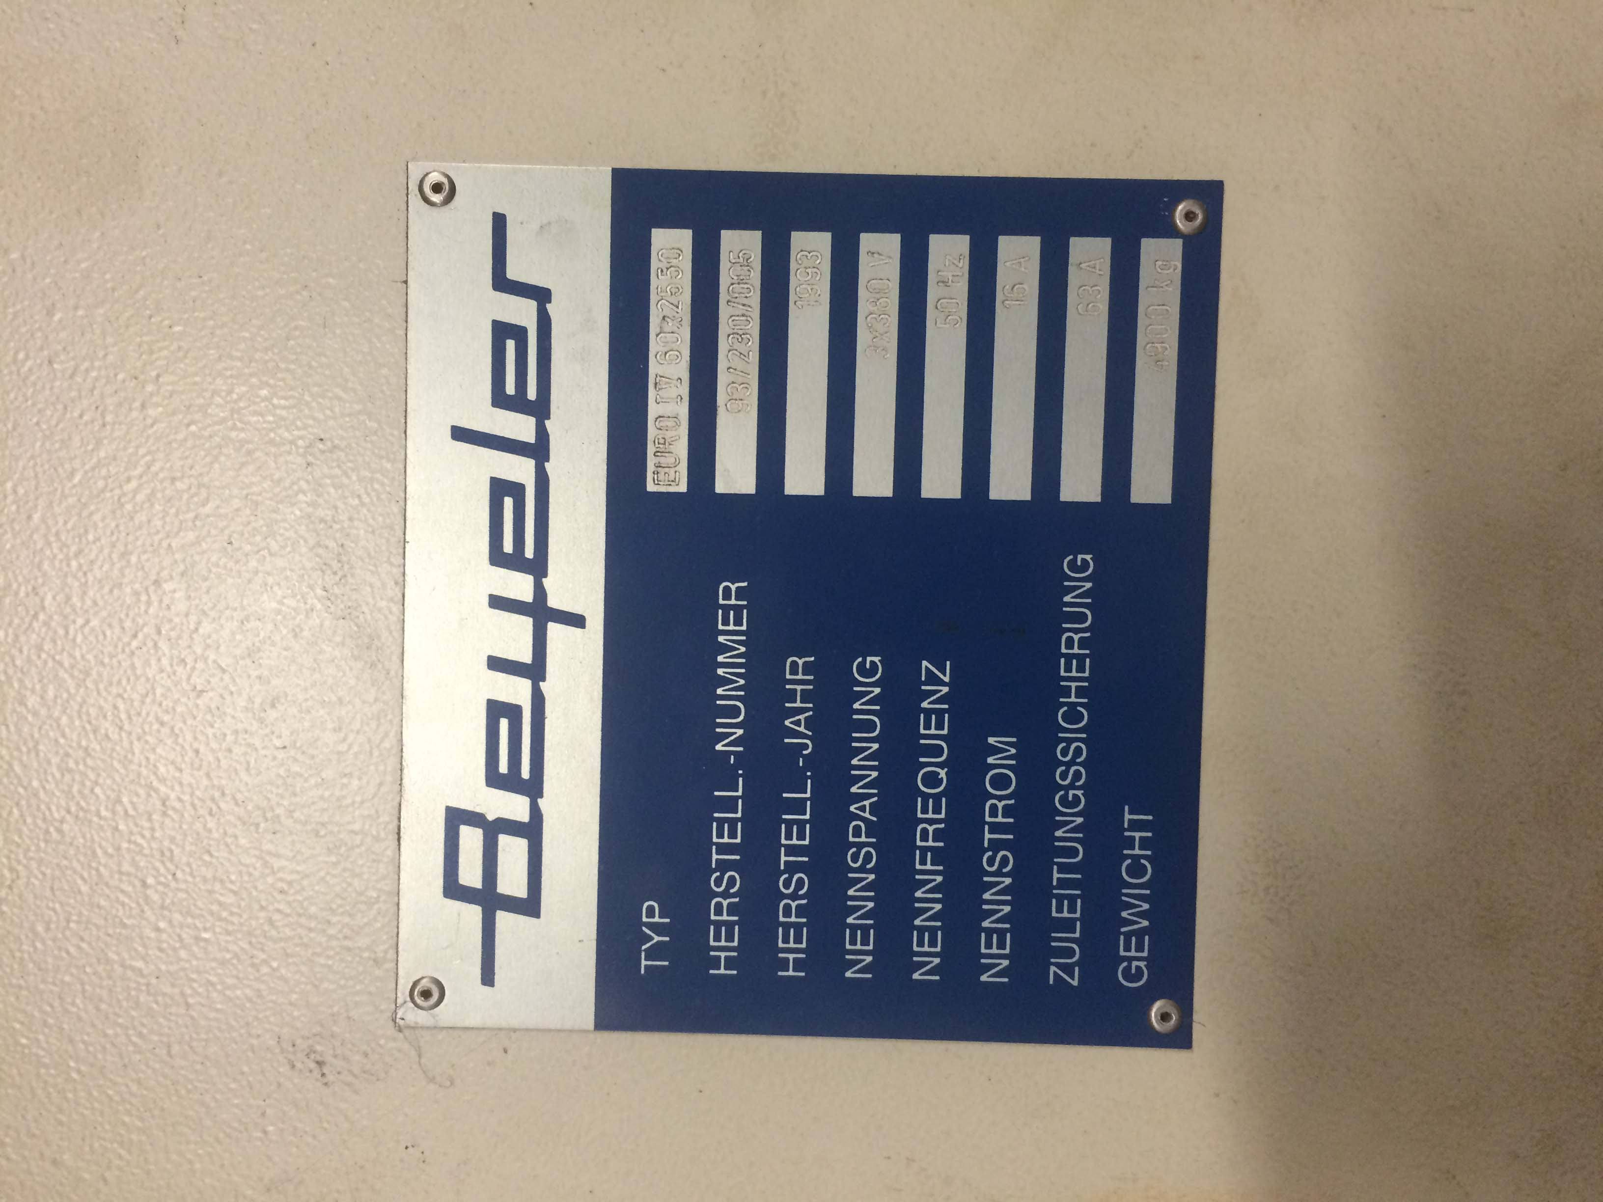

- Dimensions

- Length : 3.200
- Width : 1.450
- Height : 2.400
- Weight : 4.900
- Power : 4 kW

Please Note: The above information has been obtained to the best of our ability and belief from, and from the manufacturers where possible. It is given in good faith, but its accuracy can not be guaranteed. Accordingly, it will not form a representation or constitute contractual terms. We advise you to check any vital details!

